Ethan Elders

00099962

3/10/2024

Assignment 4

1. Postfix and Prefix Notations
   1. True
   2. OUTPUT:
      1. “The value of z is 19”
      2. “The Value of y is 18”
   3. The issue is that the “++” is not connected to a variable. You can not increment an expression.
2. Different Types of Loops
   1. Convert the following while loop to a do-while loop.

int x = 1;

do

{

cout << “enter a number: “;

cin >> x;

}

while (x > 0);

* 1. Convert the following while loop to a for loop.

int count = 0;

for (count; count < 50; count)

{

cout << “count is “ << count << endl;

}

1. Sum of Numbers
   1. 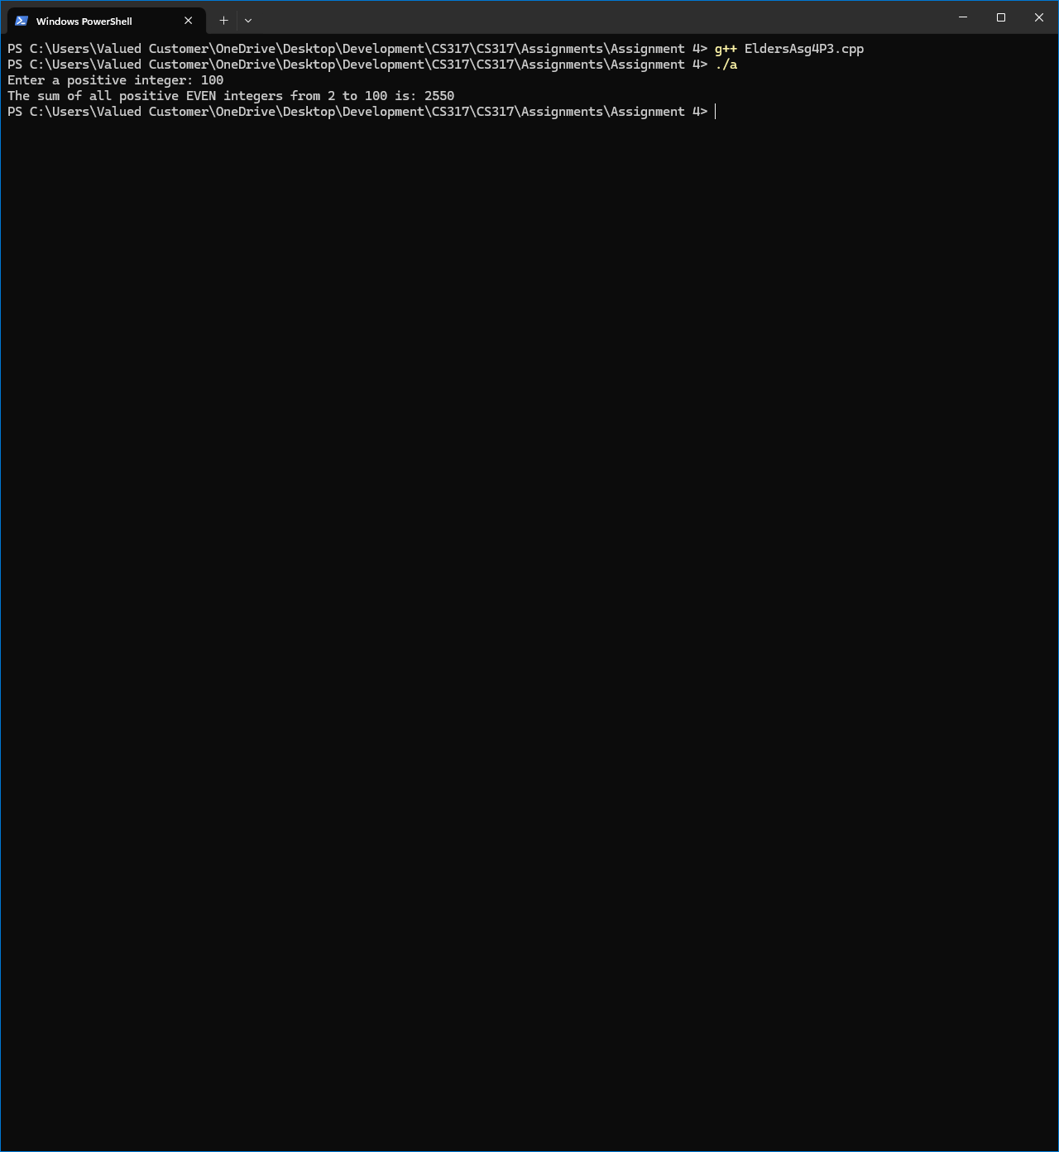
2. Grocery List
   1. 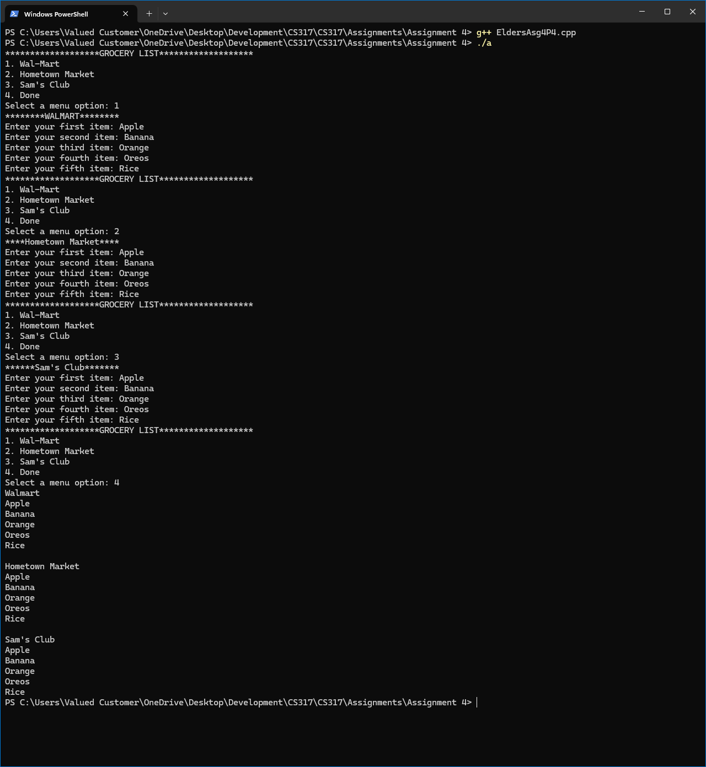
3. Using Files – Numeric Processing
   1. 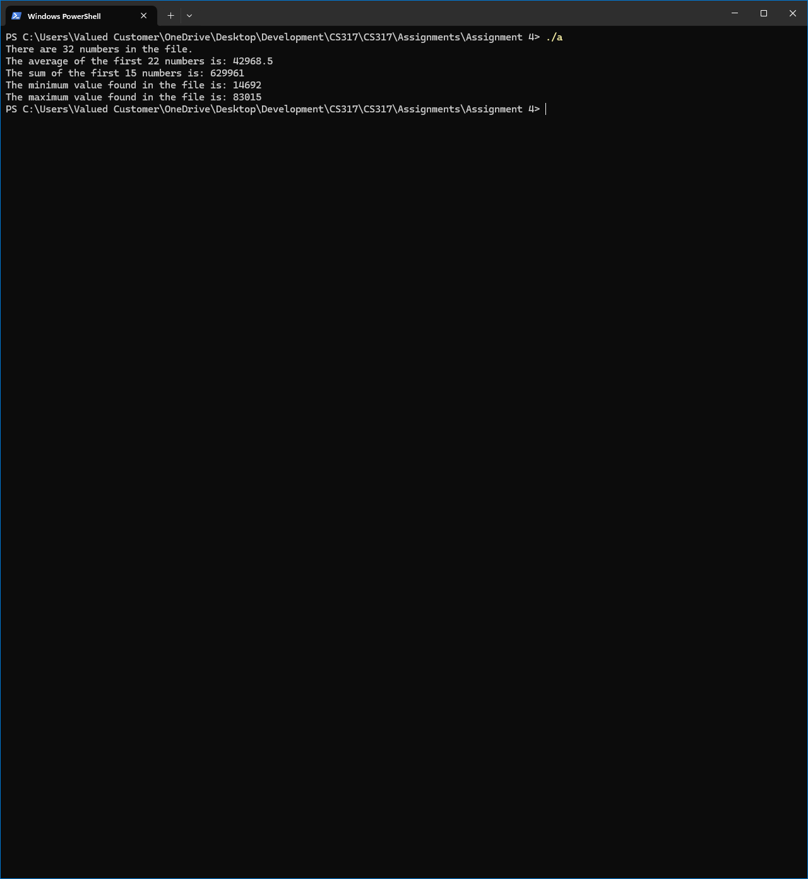
4. Stock Market Bar Chart
   1. 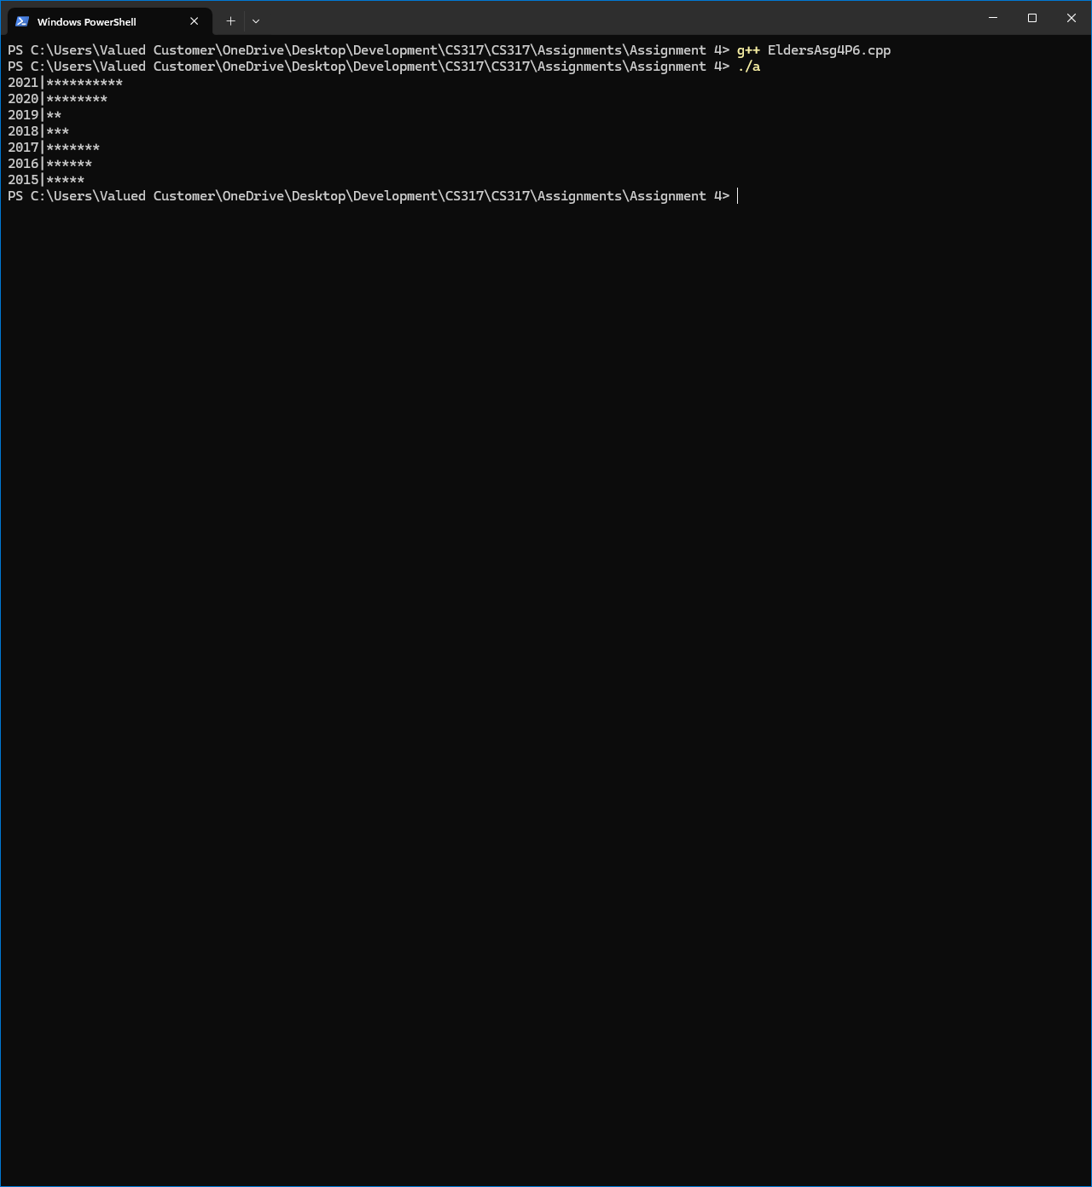
5. Improving past code
   1. 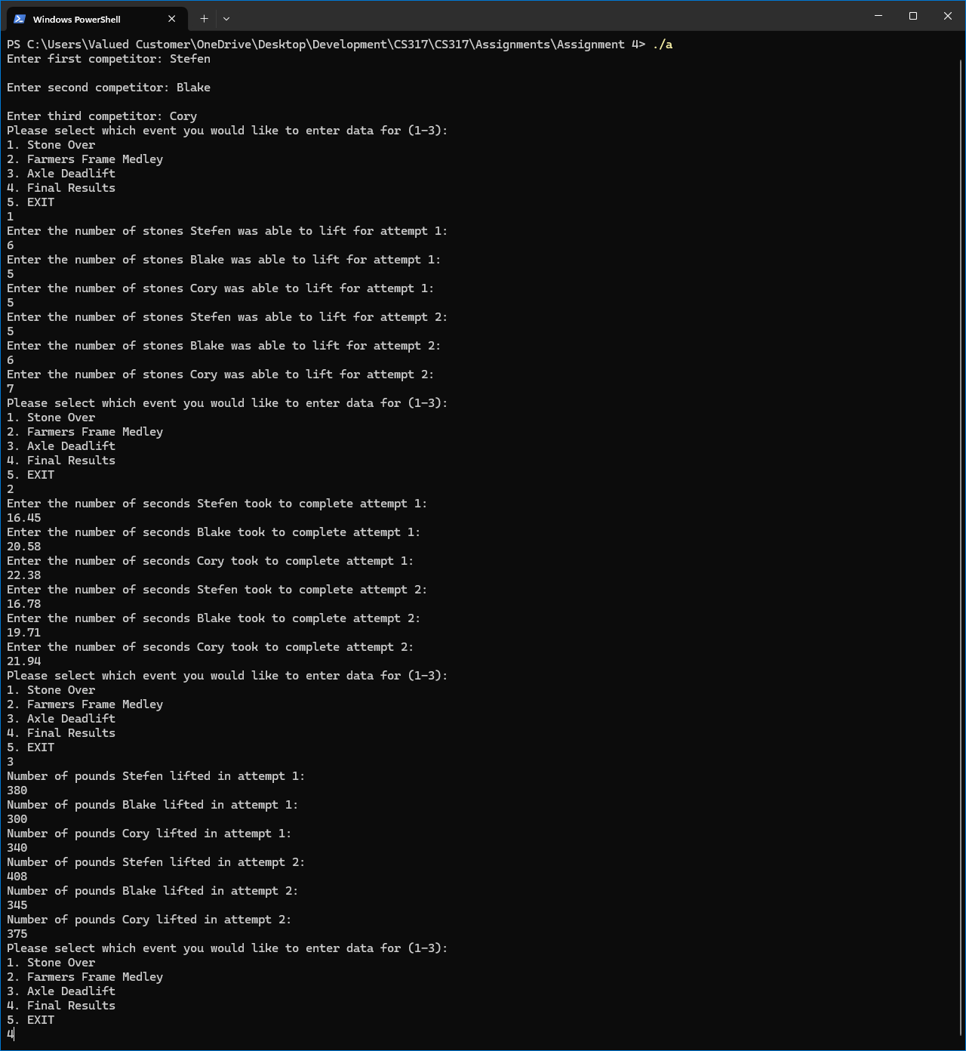
   2. 